**REPORT**

|  |
| --- |
| **Experiment 1: Measure Cut-in Voltage of the Diode** |

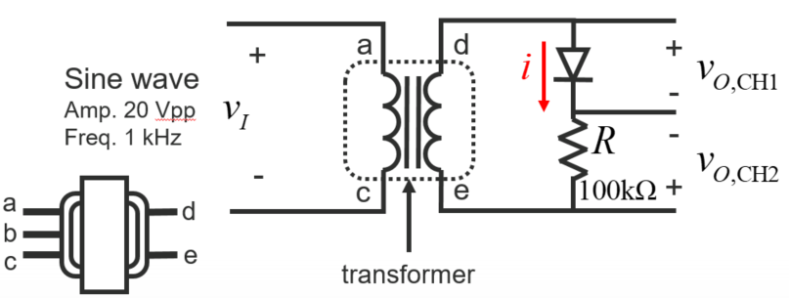

|  |  |  |  |
| --- | --- | --- | --- |
| Voltage Type | 1N4148 (Si) | LED | Zener (Si) |
| Cut-in voltage, Vr (V) | **2** | **1.8** | **0.72** |
| break down voltage(V) |  | | **5.28** |

**ADJUST THE OSCILLOSCOPE AND DISPLAY CURSOR APPROPRIATELY**

I-V curve (1N4148)

(1pic)

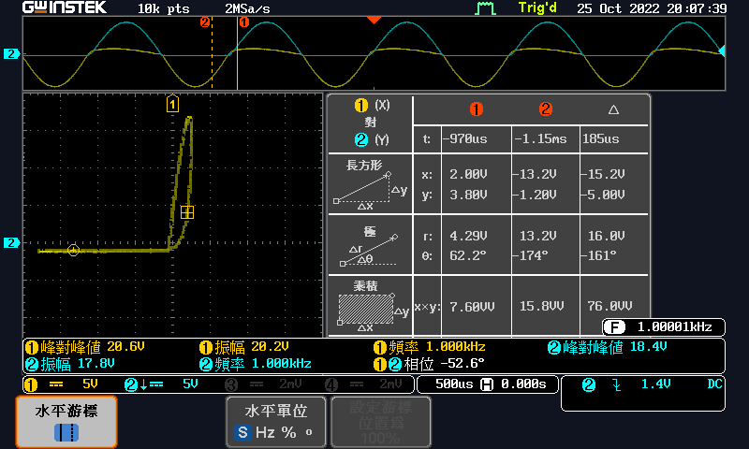

I-V curve (LED)

(1pic)

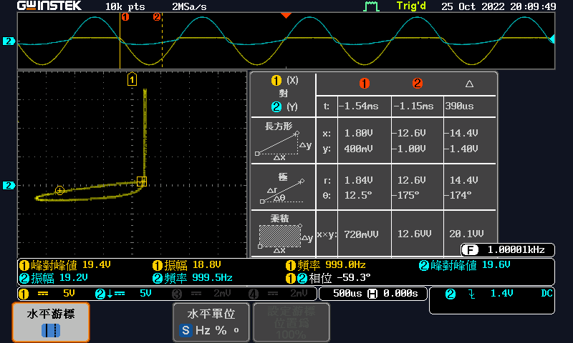

I-V curve (Zener)

(1pic)

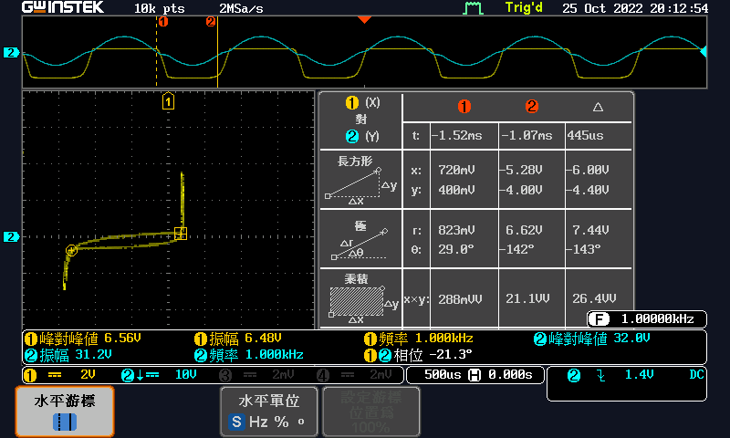

Question:

Please describe what happened when LED frequency decreasing below 100 Hz.

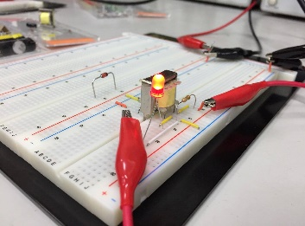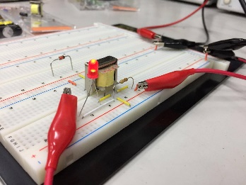

The LED light is dimmer when the frequency is below 100Hz.

|  |
| --- |
| **Experiment 2: The Characteristics of Halfwave Rectifier** |

**ADJUST THE OSCILLOSCOPE AND DISPLAY CURSOR APPROPRIATELY** 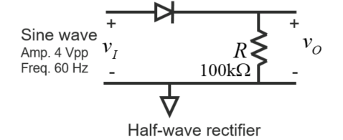

1.

vin & vout waveform in DC coupling

(1pic)

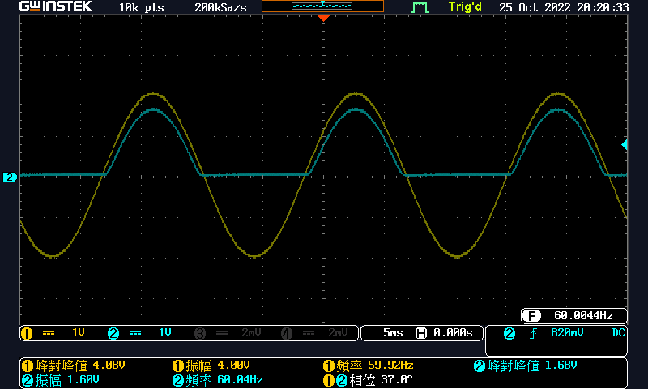

Discuss:

We can see that the bottom half of the output signal is cut, so the positive signal remains. Also, the maximum voltage of the output channel is slightly lower than the maximum voltage of input. This is because the diode has a threshold voltage, and this threshold voltage subtracts the maximum voltage of the output channel.

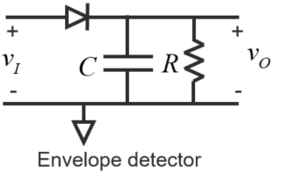

2.1

vin & vout waveform in DC coupling

(1pic)

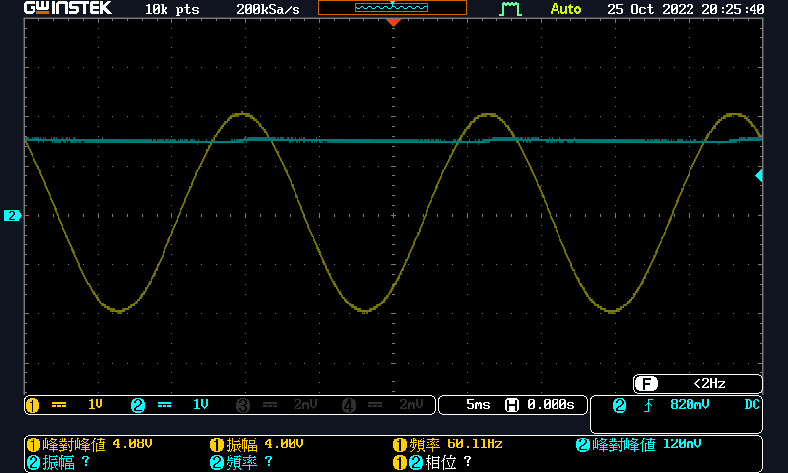

2.2

vin & vout waveform in DC coupling

(1pic)

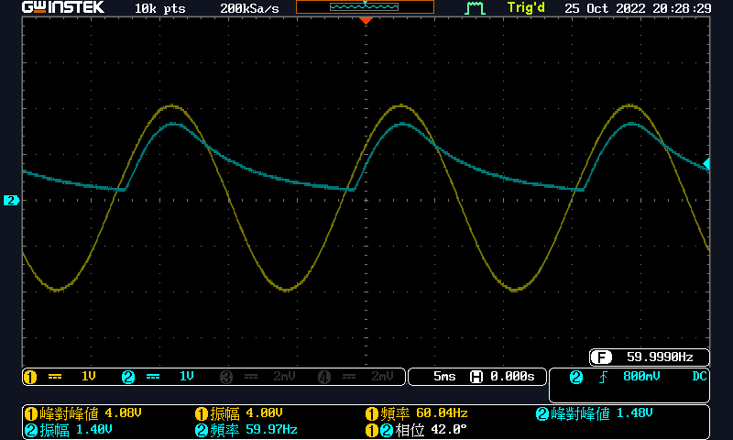

2.3

vin & vout waveform in DC coupling

(1pic)

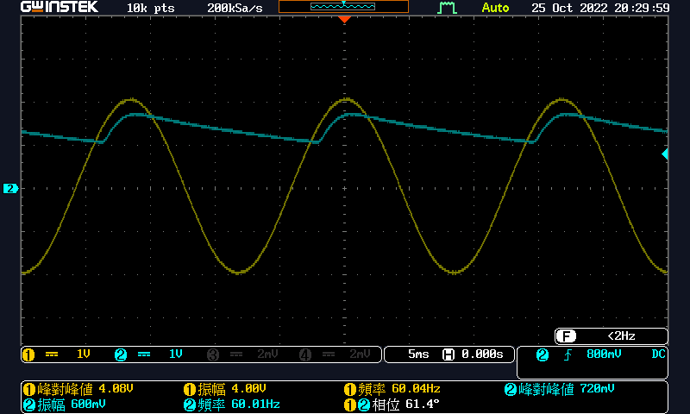

2.4

vin & vout waveform in DC coupling

(1pic)

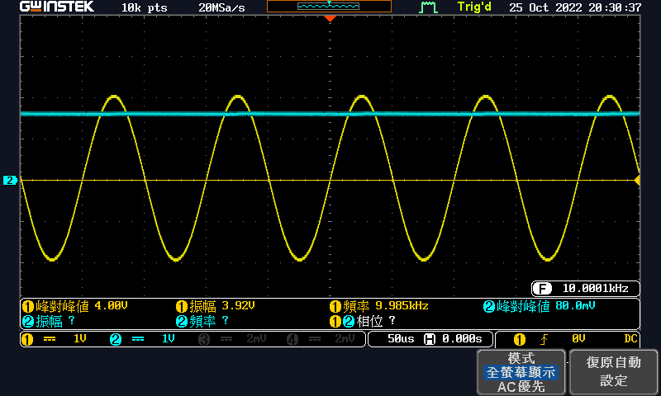

3.

vin & vout waveform in DC coupling

(1pic)

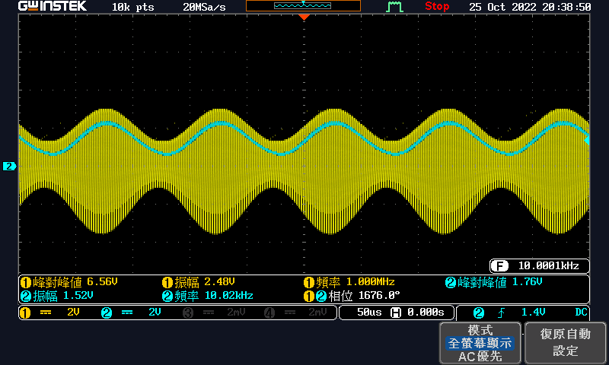

Discuss:

The capacitor smooths the voltage. We know that capacitor discharges for nearly the entire cycle, and the charge removed from the capacitor during one discharge cycle is

$$Q=I_{L}T$$

The charge removed from the capacitor is the procuct of the change in voltage and the capacitance

$$Q=V_{r}C$$

From the two equations above, we can find a formula of ripple voltage $V_{r}$

$$V_{r}=\frac{I_{L}T}{C}$$

Now let’s compare the four situations using the formula above.

Situation 1 and 2: The capacitor of situation 2 is much lower than the capacitor of situation 1. Therefore, the ripple voltage of situation 2 is higher than situation 1.

Situation 2 and 3: The load resistor of situation 3 is higher. As a result, the load current of situation 3 must be lower, and the ripple voltage will be lower than situation 2.

Situation 3 and 4: The frequency is increased to $10\text{kHz}$. The period $T$ is lower, and the ripple voltage is lower.

We also did the sine wave with AM modulation. We can see that the higher frequency somehow is smoothed. Actually, the $RC$ circuit acts as a low pass circuit and the diode cut the negative voltage out. Therefore, we have a output waveform like the diagram above.

|  |
| --- |
| **Experiment 3: Clamp circuit** |

**ADJUST THE OSCILLOSCOPE AND DISPLAY CURSOR APPROPRIATELY** 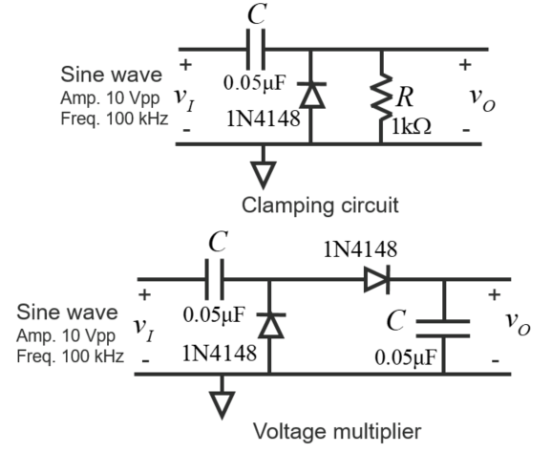

1.

vin & vout waveform in DC coupling

(1pic)

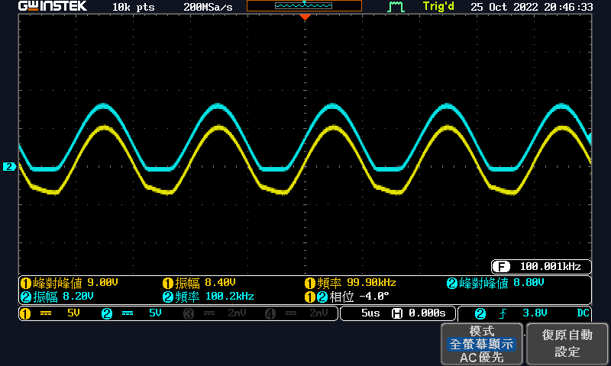



2.

|  |  |  |  |
| --- | --- | --- | --- |
|  | Type (DC or AC) | Measured | Theoretical(Vr=0) |
| vout (V) | **DC** | **9.1V** | **10** |

vin & vout waveform in DC coupling

(1pic)

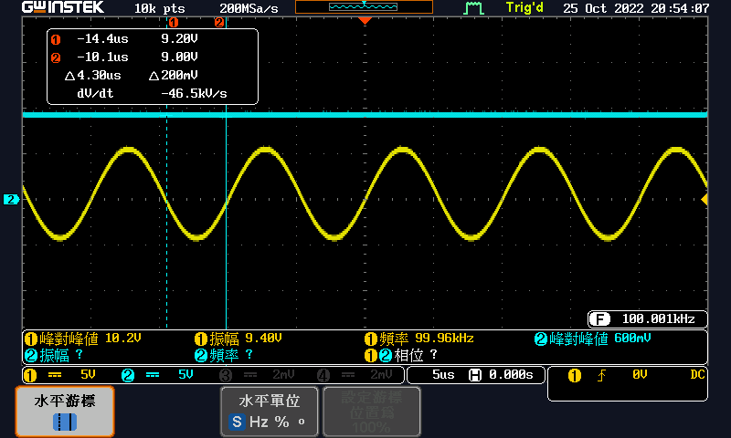

Simulation:

(2pic)

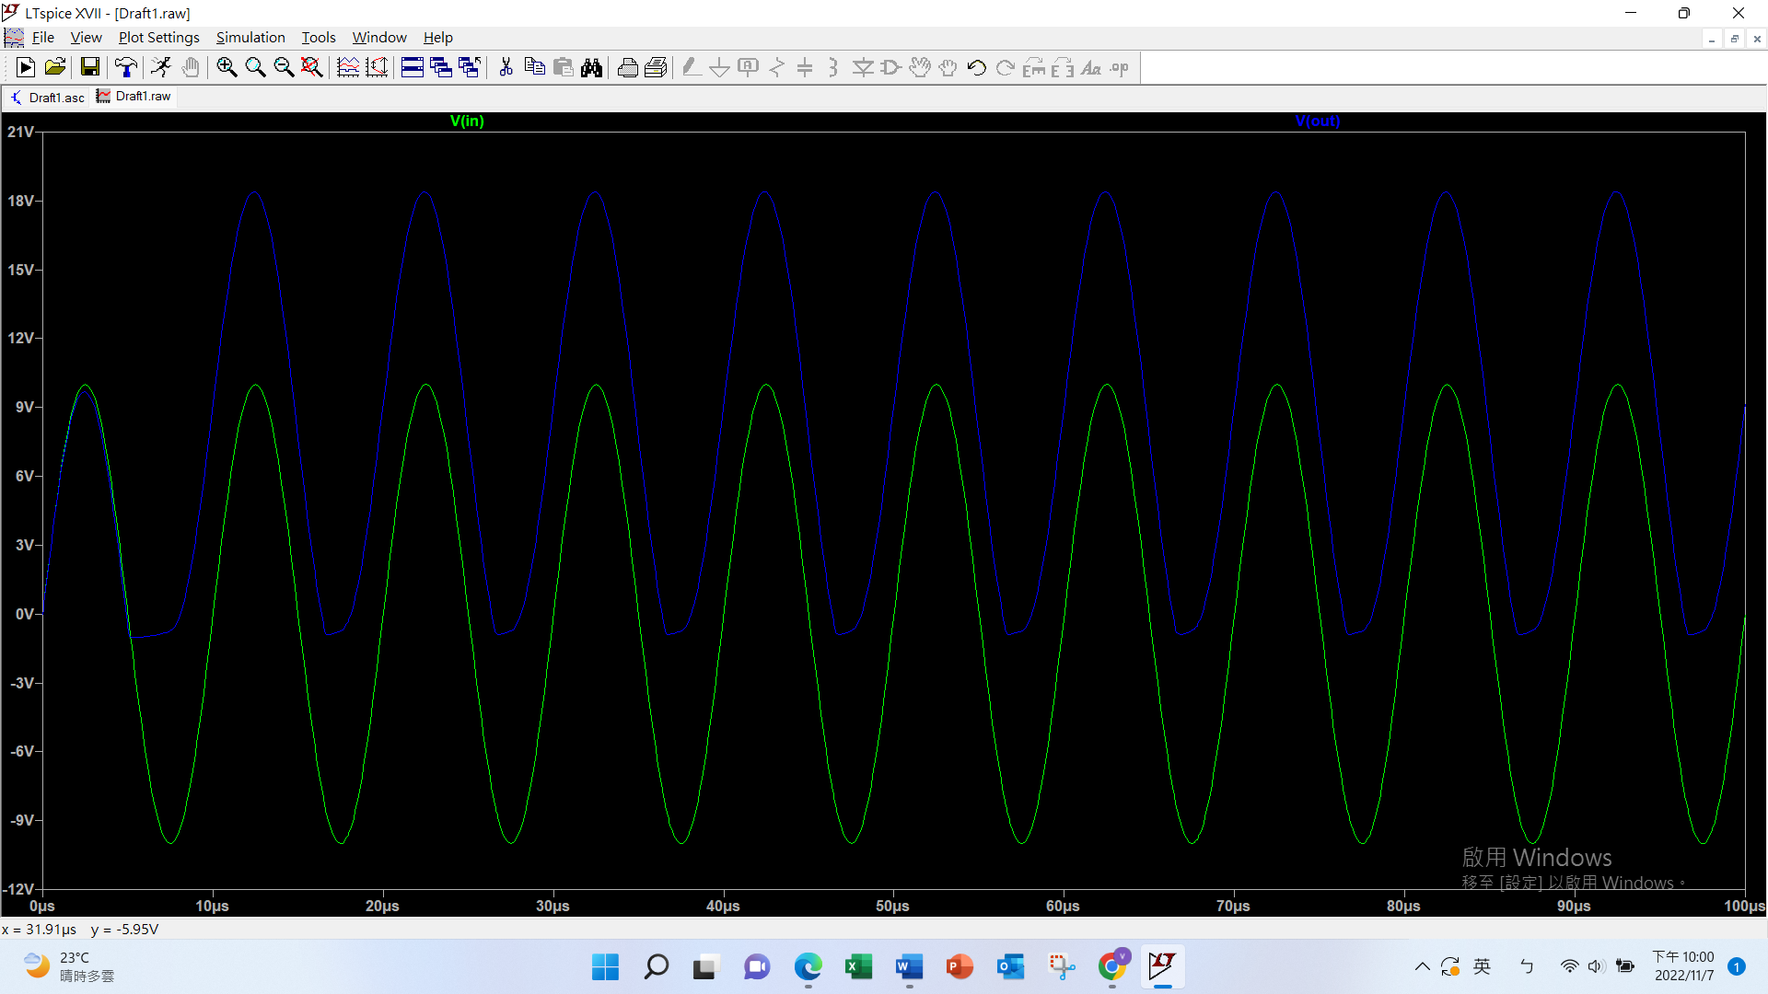

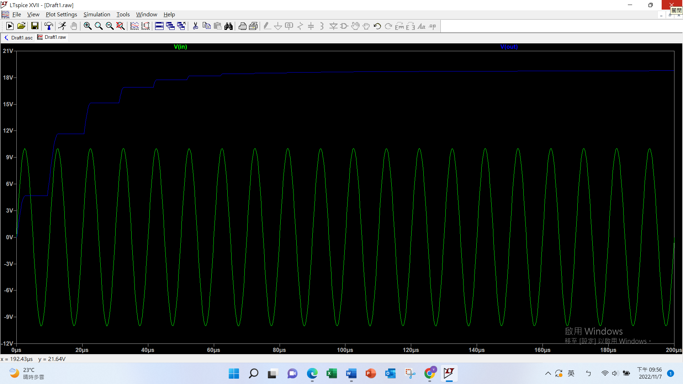

Discuss:

Clamping circuit moves the entire signal up without changing the waveform. Also, we have a envelope detector, so the output waveform should be at $10\text{V}$ (if the ripple voltage is neglected). Considering that we have a diode that has a threshold voltage, the result voltage should be lower than $10\text{V}$.